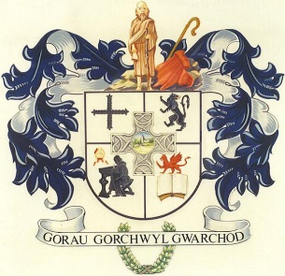
CYNGOR CYMUNED
L L A N B A D A R N F A W R
COMMUNITY COUNCIL

Clerc/Clerk: Blaenyresgair Uchaf
Mrs T Jones Tynreithyn
Tregaron
Ceredigion SY25 6lS.

Ebost/Email: ccllanbadarnfawr@hotmail.co.uk Ffôn/Tel: 01974 251269
___________________________________________________________________
Mai/May 16, 2019

At Gadeirydd a Aelodau Cyngor Cymuned Llanbadarn Fawr

Annwyl Aelod,
Cynhelir Cyfarfod o’r Cyngor yn Festri Capel Soar, Rhiw Briallu, Llanbadarn Fawr, NOS FERCHER, 22 MAI, 2019 am 6.30 hwyr.

To the Chairman and Members of Llanbadarn Fawr Community Council

Dear Member
The Meeting of the Community Council will be held at Soar Chapel Vestry, Primrose Hill, Llanbadarn Fawr, on WEDNESDAY, 22 MAY, 2019 at 6.30p.m.

Yn gywir/Yours sincerely

T Jones

Tegwen Jones
Clerc/Clerk

CYNGOR CYMUNED
L L A N B A D A R N F A W R
COMMUNITY COUNCIL
AGENDA

- Ymddiheuriadau a Materion Personol.
Apologies for absence and Personal Matters.

2. Datganiad Debryn Swydd .
Declaration of Office.

3. Datgelu Buddiannau Personol ar unrhyw fater isod.
Disclosure of Personal Interests on any of the undermentioned points.

4. Cwestiynnau’r Cyhoedd.
Questions from the public.

5. Materion Cynllunio.
Planning Matters.
Pwllhobi House, Llanbadarn Fawr, Aberystwyth – Proposed renovations and improvements.

