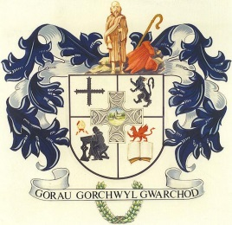
CYNGOR CYMUNED
L L A N B A D A R N F A W R
COMMUNITY COUNCIL

Clerc/Clerk: Mrs T Jones
Blaenyresgair Uchaf
Tynreithyn
Tregaron
Ceredigion
SY25 6LS
e-bost ccllanbadarnfawr@hotmail.co.uk Ffôn/Tel: 01974251269
___________________________________________________________________
Hydref 21 October, 2019

At Gadeirydd ac Aelodau Cyngor Cymuned Llanbadarn Fawr

Annwyl Aelod,
Cynhelir cyfarfod nesaf o’r Cyngor yn Festri Capel Soar, Rhiw Briallu, Llanbadarn Fawr, NOS LUN, 28 HYDREF, 2019 am 6.30 yr hwyr.

To the Chairman and Members of Llanbadarn Fawr Community Council

Dear Member
The next meeting of the Community Council will be held at Soar Chapel Vestry, Primrose Hill, Llanbadarn Fawr, on MONDAY, 28 OCTOBER, 2019 at 6.30p.m.

Yn gywir/Yours sincerely

T Jones

Tegwen Jones
Clerc/Clerk

CYNGOR CYMUNED
L L A N B A D A R N F A W R
COMMUNITY COUNCIL
AGENDA

1. a) Ymddiheuriadau/Apologies for absence.
b) Materion Personol/Personal Matters.

2. Datgelu Buddiannau Personol/Disclosure of Personal Interests.

3. Cynllunio/Planning
A190785 – Demolition of Garage and Rear Porch & Erection of an extension.
Ynys Werdd, Llanbadarn Fawr, Aberystwyth.

.

