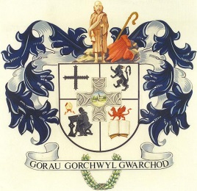
CYNGOR CYMUNED
L L A N B A D A R N F A W R
+
+++
+++++++++++++++++++++++++++++++++++++++
++++
++
++

Clerc/Clerk: Mrs T Jones
Blaenyresgair Uchaf
Tynreithyn
Tregaron
Ceredigion
SY25 6LS
e-bost ccllanbadarnfawr@hotmail.co.uk Ffôn/Tel: 01974251269
___________________________________________________________________
Rhagfyr 9 December, 2020

At Gadeirydd ac Aelodau Cyngor Cymuned Llanbadarn Fawr

Annwyl Aelod,
Cynhelir cyfarfod nesaf o’r Cyngor dros y we ar NOS LUN, 14 O RAGFYR, 2020 am 6.30 yr hwyr.

To the Chairman and Members of Llanbadarn Fawr Community Council

Dear Member
The next meeting of the Community Council will be held over the internet on MONDAY, 14 DECEMBER, 2020 at 6.30p.m.

Yn gywir/Yours sincerely

Rhian

Rhian Rowlands ar ran/on behalf of
Tegwen Jones
Clerc/Clerk

CYNGOR CYMUNED LLANBADARN FAWR COMMUNITY COUNCIL
AGENDA

1. Materion Personol/Personal Matters.

2. Datgelu Buddiannau Personol/Disclosure of Personal Interests.

3. Unrhyw gwestiwn gan y cyhoedd/Any questions from the public.

4. Unrhyw gwynion at sylw’r Heddlu/Any complaints for the attention of the Police.

5. I gadarhau y canlynol/to confirm the following:
i. cofnodion y cyfarfod misol a gynhaliwyd ar 23 Tachwedd, 2020.
i. the minutes of the monthly meeting held on 23 November, 2020.

6. Materion yn codi o’r cofnodion uchod/Matters arising from the above Minutes.

7. Materion Cynllunio/Planning Matters.

8. Gohebiaeth/Correspondence.

9. Ariannol/Financial

10.Clerc yn absenldeb Mrs T Jones/Clerk in the absence of Mrs T Jones.

11. Sion Corn/Father Christmas

12. Sedd wag/Vacant seat

.

