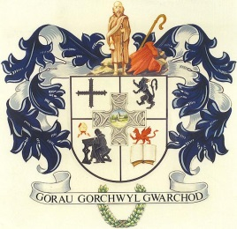
CYNGOR CYMUNED
L L A N B A D A R N F A W R
COMMUNITY COUNCIL

Clerc/Clerk: Mrs T Jones
Blaenyresgair Uchaf
Tynreithyn
Tregaron
Ceredigion
SY25 6LS
e-bost ccllanbadarnfawr@hotmail.co.uk Ffôn/Tel: 01974251269
___________________________________________________________________
Mawrth 10 March, 2021

At Gadeirydd ac Aelodau Cyngor Cymuned Llanbadarn Fawr

Annwyl Aelod,
Cynhelir cyfarfod nesaf o’r Cyngor dros y we ar NOS LUN, 15 Mawrth, 2021 am 7.00 yr hwyr.

To the Chairman and Members of Llanbadarn Fawr Community Council

Dear Member
The next meeting of the Community Council will be held over the internet on MONDAY, 15 MARCH, 2021 at 6.30p.m.

Yn gywir/Yours sincerely

T Jones

Tegwen Jones
Clerc/Clerk

CYNGOR CYMUNED LL A N B A D A R N F A W R COMMUNITY COUNCIL
AGENDA

1. Ymddiheuriadau/Apologies.

2. Datgelu Buddiannau Personol/Disclosure of Personal Interests.

3. Unrhyw gwestiwn gan y cyhoedd/Any questions from the public.

4. Materion Cynllunio/Planning Matters.
A210144 – Yr Hen Stal, Heol Iawn, Llanbadarn Fawr.

5. Gohebiaeth/Correspondence.

6. Ariannol/Financial.
Biliau wedi/i’w talu
Accounts paid/for payment.

.

